How we can make our site Multilingual

1. Put the js file on the index page create the bundles:
<script src="~/Scripts/angular-cookies.js"></script>
<script src="~/Scripts/angular-translate.js"></script>
<script src="~/Scripts/angular-translate-loader-url.js"></script>

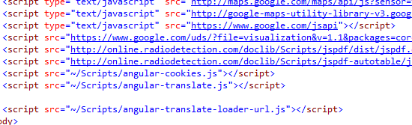

2.After that inject the following in our module: 'ngCookies', 'pascalprecht.translate'.

3.In app.config put the translate provider which is :$translateProvider.

4.After putting this we use urlloader for heat the web api using some line of code: $translateProvider.useUrlLoader('/api/account/Get');

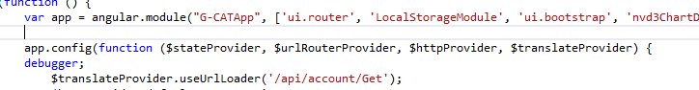

5.In Login Controller of js file we declare the following: '$cookies', '$translate'

6.After that we will create two function in this controller one is setLanguage(Lan) in which language will be as a parameter,and second one is init() finction which will call on page load.
and default value of lan is set en.

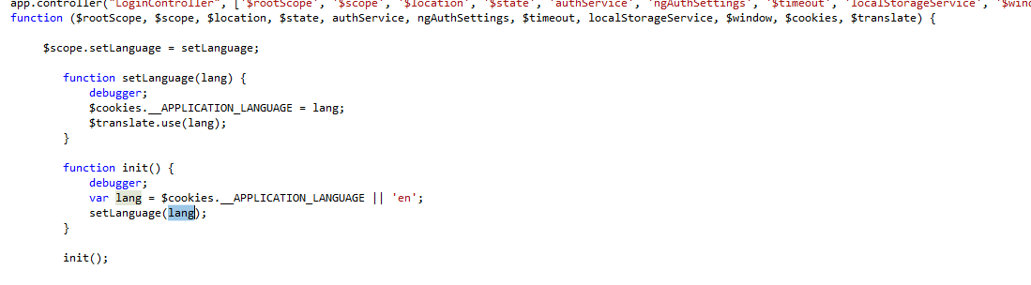

7.Now is C# code Gloable.aspx file we create Application_BeginRequest() function. in this function we get the value of cookie and set the culture and UiCulture for that language.

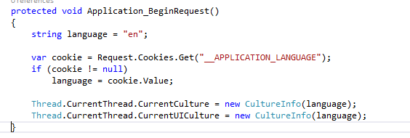

8.In account Controller we will Create Get Function on which api heat and get resource for selected language.

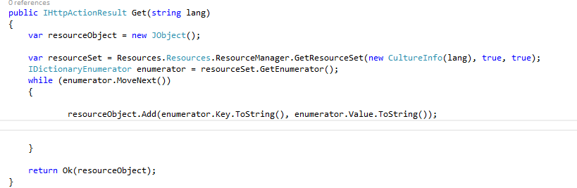

9.Add the Resource for all the three languages and embedded them with Resource.Designer class in Resource folder.

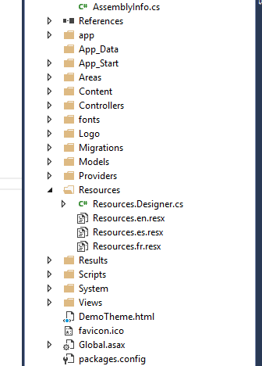

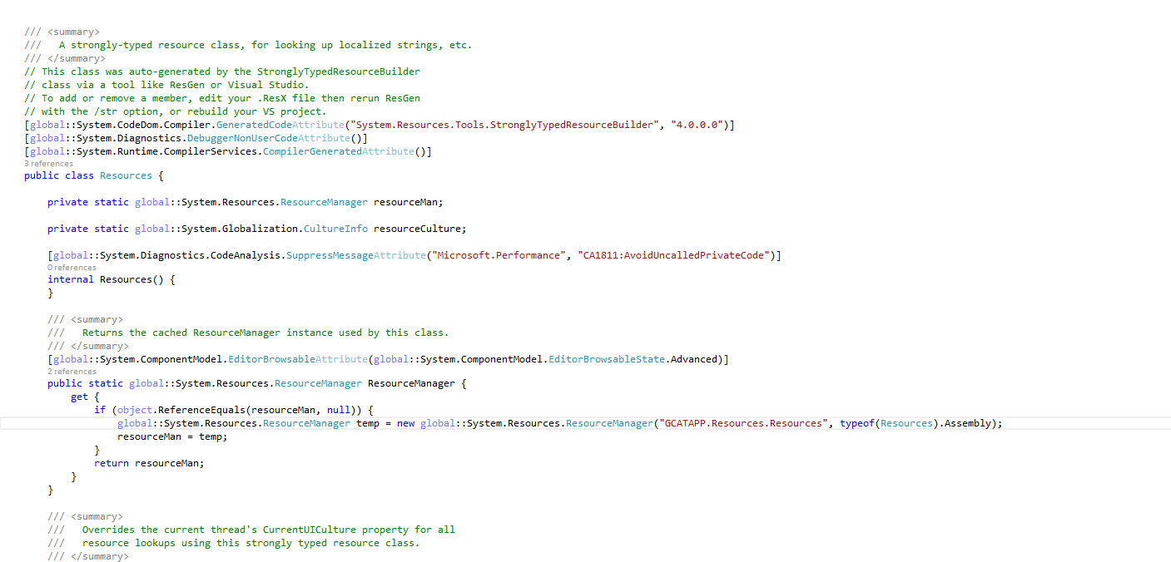

10.Put the translate attribute on the element which we want to translate into other language.
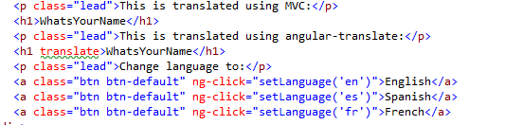
11.Final OutPut:-

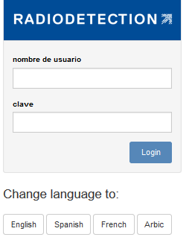
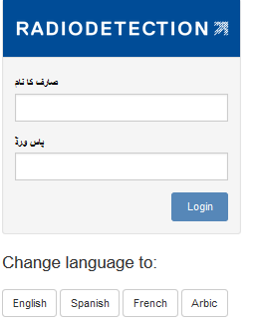

URFX – Multi linguial support :

1. protected void Application_BeginRequest()
{
string language = "en";

var cookie = Request.Cookies.Get("__APPLICATION_LANGUAGE");
if (cookie != null)
language = cookie.Value;

Thread.CurrentThread.CurrentCulture = new CultureInfo(language);
Thread.CurrentThread.CurrentUICulture = new CultureInfo(language);
}

This is set at begin request as per cookie value stored.

- LanguageMessageHandler class at root that handle all request from api that set language as per accept-language value.

- LanguageMessageHandler called at webapicongig at app_start that trigger its functions.
- config.MessageHandlers.Add(new LanguageMessageHandler());

public static class CommonFunctions
{
public static string ReadResourceValue(string Value)
{
string resourceValue = string.Empty;
try
{
resourceValue = Resources.ResourceManager.GetString(Value);
return resourceValue;

}
catch (Exception ex)
{
resourceValue = Value;
}
return resourceValue;
}
}

This function is used whenever we want to get value from resource file.
List<ServiceProviderModel> serviceProviderList = new List<ServiceProviderModel>();
serviceProviderList = serviceProviderService.GetAllServiceProviders().Select(x => new ServiceProviderModel()
{
CompanyLogoPath = x.CompanyLogoPath,
CompanyName = CommonFunctions.ReadResourceValue(x.CompanyName),

